Reptial and Amphibian Study
Worksheet by the Merit Badge Center, Philippines

Last Updated: March 22, 2021

This worksheet was created to assist Scouts with their merit badge work. The worksheet does not replace the actual merit badge counseling process. A certified merit badge counselor for the badge must still certify your completion of each requirement and the merit badge. If a requirement says that you must take an action using words such as “discuss”, “show”, “tell”, “explain”, “demonstrate”, “identify”, etc. that is what you must do. Merit badge counselors may not require the use of this worksheet or any similar material. No one may add, subtract, or modify the official requirements for the merit badge as prescribed by the Boy Scouts of the Philippines.

Scout’s Name: ___________________________________________ Unit: _________________________

Requirement 1. Make sketches from your own observation, showing markings and color patterns of five reptiles and three amphibians found in your province, and record the habitat and habits of each species.

Make sketches from your own observation, showing markings and color patterns.

Reptile # 1 |  | Reptile # 2

Reptile # 3 |  | Reptile # 4

Reptile # 5 |  | Amphibian # 1

Amphibian # 2 |  | Amphibian # 3

Record the habitat and habits of each species.
 | Species | Habitat | Habits
Reptile # 1
Reptile # 2
Reptile # 3
Reptile # 4
Reptile # 5
Amphibian # 1
Amphibian # 2
Amphibian # 3

Requirement 2. Know approximately the number of species and general distribution of reptiles and amphibians in the Philippines.

Use the map below to show the approximate number and distribution of reptiles and amphibians.

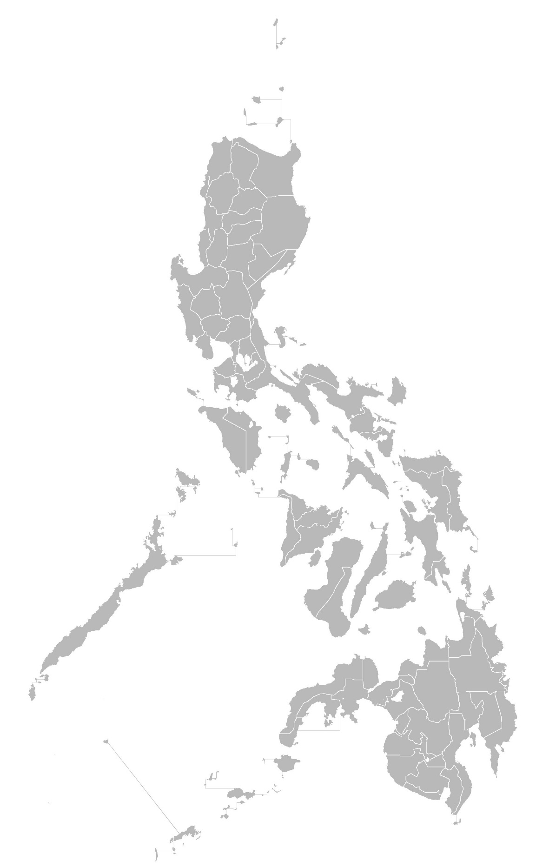

Requirement 3. Describe how reptiles and amphibians reproduce themselves.

Describe how reptiles reproduce themselves.

Describe how amphibians reproduce themselves.

Requirement 4. Give ten (10) superstitions about snakes, and correct explanation in each case.

# | Superstition About Snakes | Correct Explanation
1
2
3
4
5
6
7
8
9
10

Requirement 5. Identify five (5) poisonous snakes and lizards found in the Philippines, and describe their habits. Name those found in your own province. Demonstrate first aid treatment for snake bite.

Identify five (5) poisonous snakes and lizards found in the Philippines, and describe their habits.
# | Snake and Lizards | Habits
1
2
3
4
5

Name poisonous snakes and lizards found in your own province.
1.
2.
3.
4.
5.

Have your Merit Badge Counselor certify you have demonstrated first aid treatment for snake bite.

___________________________________ _____________
Merit Badge Counselor’s Signature Date

Requirement 6. List ten (10) reptiles or amphibians useful to man either as food or in controlling insects or rodent pests, and state how food is taken. List food habits of each species. If there are laws for their protection, tell reasons why they are protected.

# | Reptile or Amphibian  Name | How Food is  Taken | Food Habit of  this Specie | If protected, write the reason why they are protected
1
2
3
4
5
6
7
8
9
10

Requirement 7. From actual observation, describe how reptiles move forward. Describe the functions of the muscles, ribs, and belly plates.

Describe how reptiles move forward.

Describe the function of the muscles.

Describe the function of the ribs.

Describe the function of the belly plates.

Requirement 8. Describe the outstanding differences between the following: alligators and crocodiles, toads and frogs, newts and other salamanders, salamanders and lizards.

Alligators |  | Crocodiles

Toads |  | Frogs

Newts |  | Other Salamanders

Salamanders |  | Lizards

Requirement 9. Maintain in a terrarium, aquarium, or properly constructed cage one or more reptiles or amphibians (non-poisonous only) for at least a month. Record the food accepted, the method employed in eating, changes in color or skin shedding, and general habits during this period. Or keep the eggs of one amphibian or reptile from the time of laying until hatching, and record the length of time required for hatching and the method of hatching.

Enclosure Type: Terrarium Aquarium Constructed Cage

What reptile or amphibian did you care for? _____________________________________________________

Record for one month.
Day | Food Accepted | Eating Method | Change in Skin Color  Skin Shedding | General Habits
1
2
3
4
5
6
7
8
9
10
11
12
13
14
15
16
17
18
19
20
21
22
23
24
25
26
27
28
29
30
31
Reptile or Amphibian Egg Kept: ______________________________________________________________

Date Egg was Laid: ________________________

Date Egg Hatched: ________________________

Method of Hatching.

Requirement 10. Go out at night and identify three kinds of toads or frogs by their voices. Stalk each with a flashlight and discover how each sings, and from where (water, in tree, etc.) Imitate for your Counselor the song of each; or take a recognizable photograph of a turtle, a snake, and an amphibian. Photographs must be from living specimens.

Identify three kinds of toads or frogs by their voice.
Toad or Frog | How it Sings | Where it Sings

Imitate for your Merit Badge Counselor the song of each.

_________________________________ _____________
Merit Badge Counselor’s Signature Date

OR

Take recognizable photographs.

Turtle

Snake

Amphibian

Show the photographs to your Merit Badge Counselor.

_________________________________ _____________
Merit Badge Counselor’s Signature Date

